**SCHOOL OF COMPUTER SCIENCE**

**UNIVERSITY OF PETROLEUM AND ENERGY STUDIES**

**DEHRADUN, UTTARAKHAND**

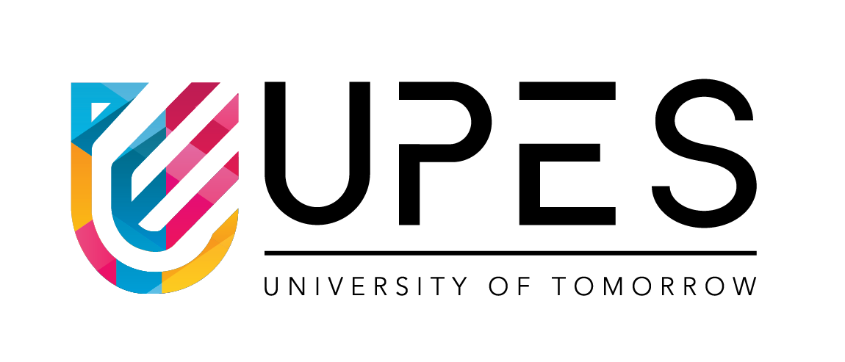

**FORM STUDIES**

**Assignment File**

**(2024-2025)**

**For**

**Vth Semester**

**Submitted To: Submitted By:**

Prof. Nikhil Tikhe Mr. Akshat Negi

Assistant Professor S.S. 500106533 (SAP ID)

[Vth Semester] R2142220414 (Roll No.)

School of Design B.Tech. CSF (Batch - 1)

**Assignment – 2**

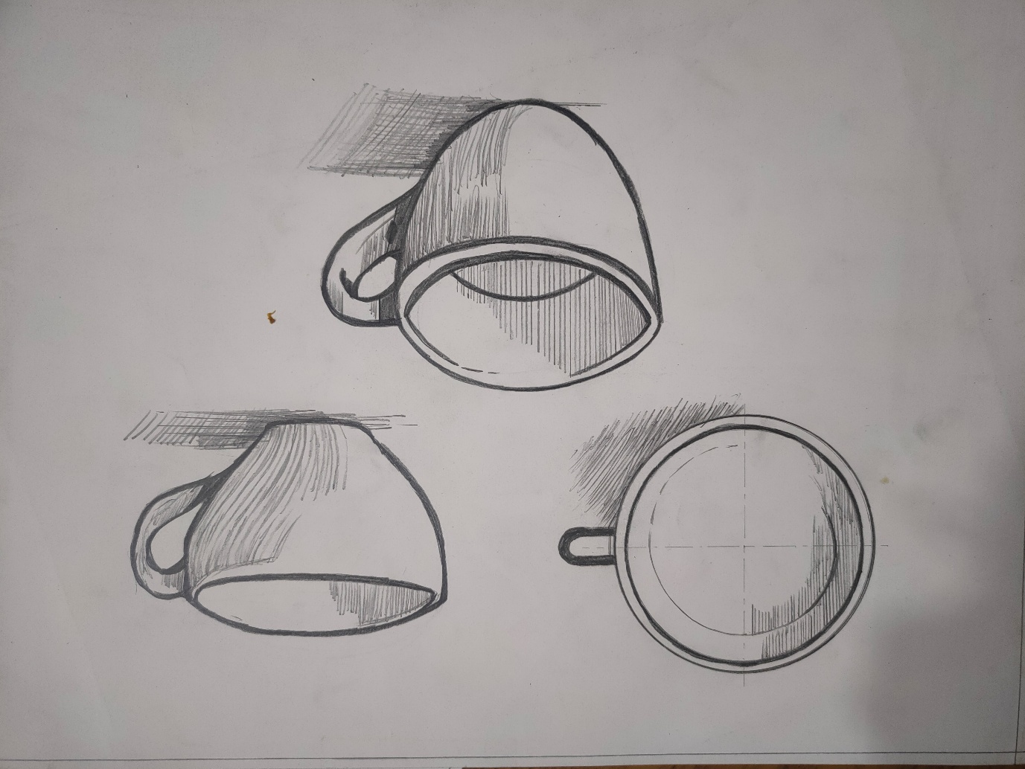

**Form 1: Form and Function**

**Top View:** The circular top view shows a wide opening that allows for easy access to the contents, making it convenient for pouring and drinking. The round shape also helps with even heat distribution, which keeps the beverage warm for longer.

**Side View:** The cup’s curved body provides a comfortable holding experience, allowing users to cradle it naturally. The gradual tapering towards the bottom gives the mug an ergonomic design, while the thick walls offer insulation, preventing the exterior from becoming too hot to touch.

**Perspective View:** The handle, shown from a perspective view, is designed with a slight curve, fitting comfortably in the hand and allowing for a firm grip. Its positioning and thickness distribute weight evenly, reducing strain on the wrist. The overall form is simple and functional, balancing both comfort and stability for everyday use.

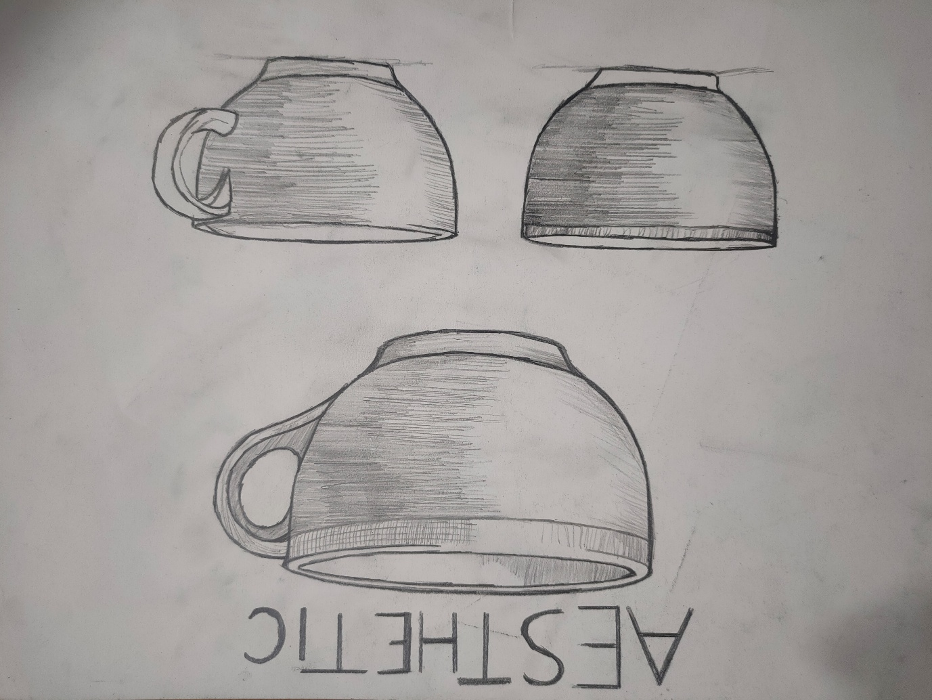

**Form 2: Form and Aesthetic**

Annotation based on the mug's aesthetic-focused design:

**Front View:** The mug displays a harmonious and balanced shape, with a symmetrical, rounded body that conveys a sense of calm and elegance. The smooth, unbroken curvature from the base to the rim adds to the cohesive look, giving the mug a sense of unity and simplicity. The proportions of the mug are carefully chosen, with a slightly wider upper half that tapers gently toward the base, creating visual stability and balance.

**Perspective View:** In this view, the handle stands out as a thoughtfully designed element, with a subtle curve that complements the mug's rounded form. The handle’s thickness and slight inward curve provide both aesthetic continuity and a sense of sturdiness. The horizontal line patterns add texture and rhythm, enhancing the visual interest without distracting from the overall minimalistic design. This combination of smooth curves, symmetry, and textured detailing creates an elegant, aesthetically pleasing piece ideal for a refined yet functional

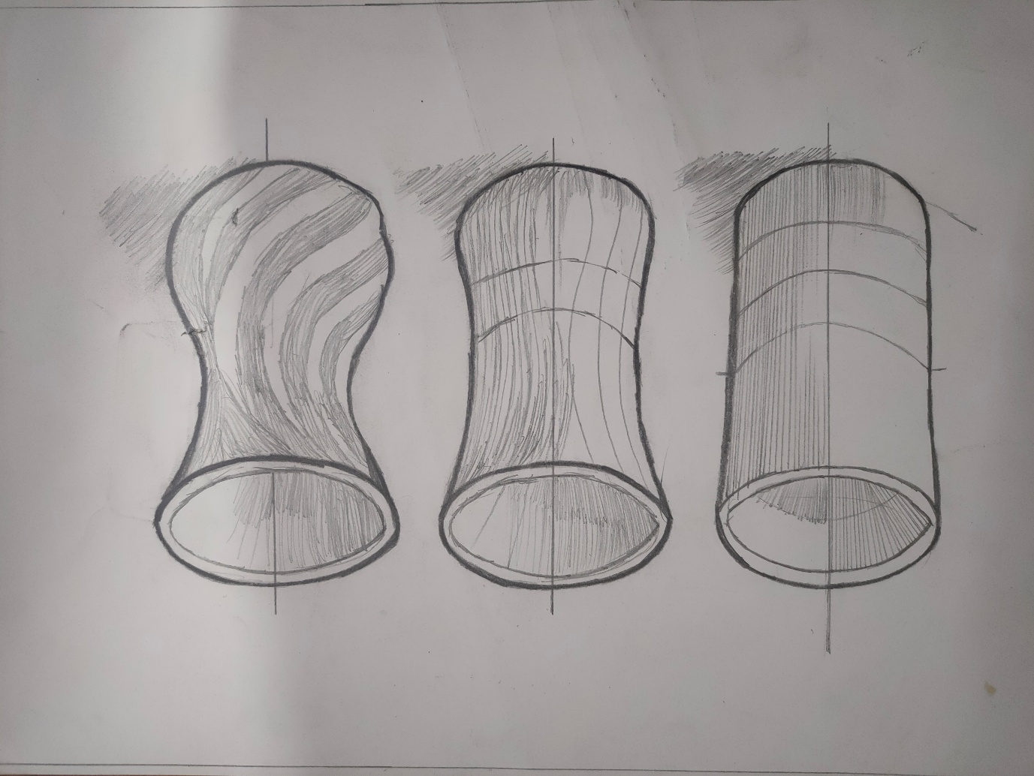

**Form 4: Form Manipulation**

**Original Form:** The vase begins with a simple cylindrical shape, featuring a straight vertical profile and a flat base, which makes it stable and functional. This base form offers an ideal starting point for further modifications.

**Manipulated Version 1:** The first transformation involves slightly increasing the height and adding a gentle inward curve near the middle, which introduces a sense of elegance and elongation. This change enhances the aesthetic appeal while still maintaining the vase's core functionality.

**Manipulated Version 2:** In the final iteration, the vase’s surface is transformed with a twisting effect, creating soft curves that flow around the form. This manipulation adds a dynamic quality, making the vase appear more organic and visually engaging. The twisted lines not only contribute to an artistic appearance but also suggest movement and softness, enhancing the vase's appeal as a decorative piece. This creative transformation takes a basic shape and reimagines it into an artistic object that combines functionality with